# PD220V-II Customer Display

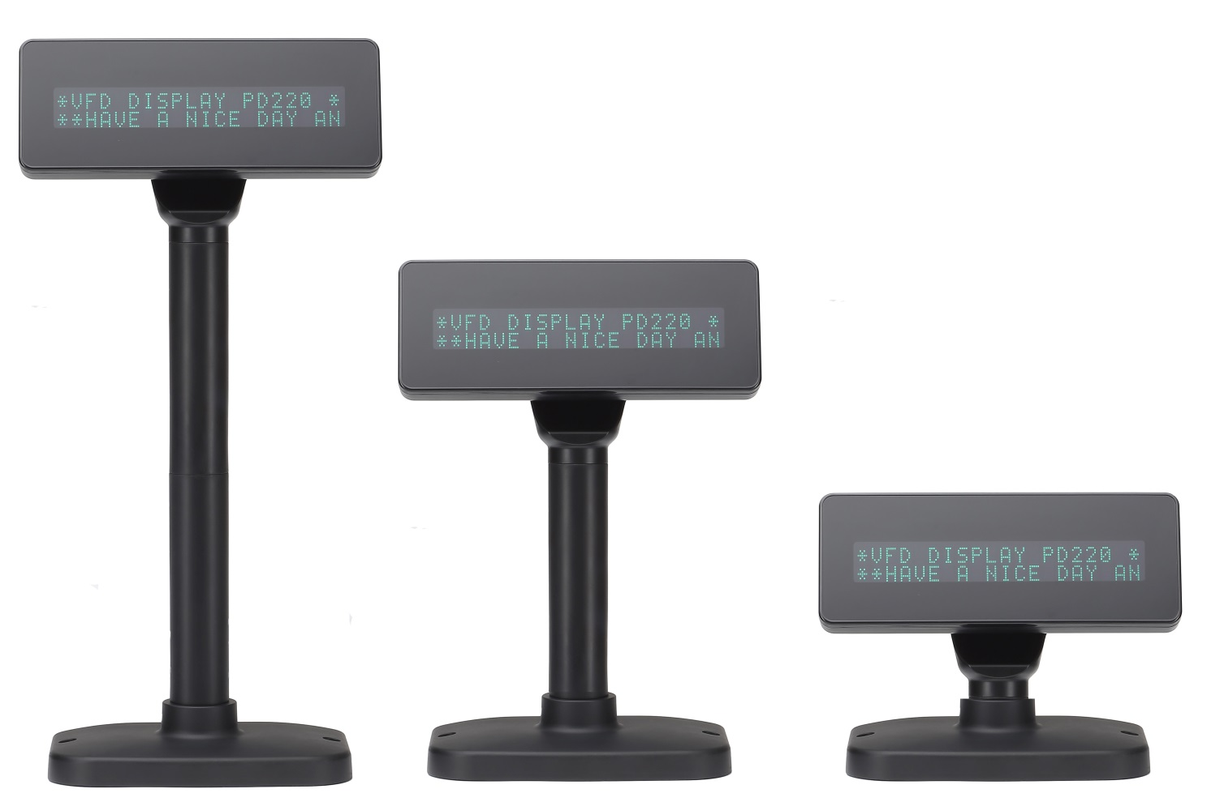

* Supports 11 command modes included EPSON etc.

* Power supply from 5V to 24V to prevent any mindless use of improper power input.

* 20-column x 2-line dot matrix in a wide viewing angle.

* Easy connectivity to a wide range of POS products.

* OPOS/JPOS driver is standard.

PD220V-II **Customer Display**

Specification

|  |  |  |  |
| --- | --- | --- | --- |
| General | Display Method | | Vacuum Fluorescent Display (Blue-green) |
| Number of characters | | 40(20 columns x 2 lines) |
| Brightness | | 500~1000 cd/m2 |
| Character font | | 5 x 7 dot matrix |
| Character type | | 95 Alphanumeric, 32 International Characters |
| Character size | | **9.03(H) x 5.25(W) mm** |
| Dot Size (X x Y) | | **0.85 x 1.05mm** |
| Download characters | | 9 characters |
| Panel Dimension | | **200(W) x 77.5(D) x31(H)mm** |
| Pole Dimension | | Per support length: 140(L) x 34.5(Dia)mm |
| Base Dimension | | 169.5(W) x98.5(D) x39(H)mm |
| Viewing Angle | | Max. 90° |
| Horizontal Rotation | | Max. 355° |
| Weight | | Approx. 980 grams |
| Commands Mode | | | LD220, EPSON POS D101, AEDEX, UTC/S, UTC/P, ADM788, DSP800, CD5220, EMAX, LOGIC CONTROL，ICD2002，EZ-202，PL-200，PD3000 |
| Language Support | | | FRANCE、GERMANY、U.K、DENMARKI、SWEDEN、ITALY、SPAIN、JAPAN、NORWAY、DENMARKII、SLAVONIC、RUSSIA、Portuguese、Canadian French、Nordic、Turkish、Greek、West European Latin、CP858、CP860、WPC1252、CP857(TURKISH)、polish、wpc1250、wpc1253（GREEK）、wpc1255（Hebrew）、wpc1251、CP866、CP852、CP737（DOSgreek）、CP858、CP864（ Arabic）、Farsi（ Iran） |
| Interface | | | RS-232(serial) / USB |
| Connection | | Baud rate | Direct connection 9600 or 19,200 bps |
| Reliability | | MTBF | 30,000 hours |
| Power | | Consumption | 5~24 VDC |
| Safety | | EMC standards  Safety standards | FCC, CE,ROHS |